MPJ Express v0_35PO1

## Installation

1. Unpack mpj-v0_35PO1.zip to N:\mpj-v0_35PO1 directory.
2. Create a new folder in N: drive and name it “mpj-user”. This will be the working directory for MPJ Express programs.





## Running MPJ Express

### Running mpjdaemon

1. Open a command prompt.

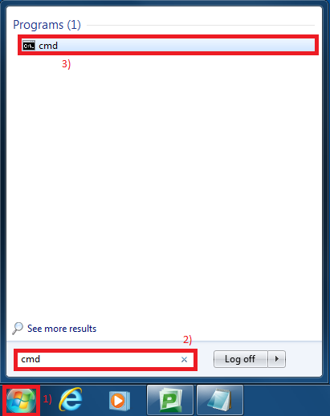

1. Set the system variables.
2. Set the value of variable MPJ_HOME.

> set MPJ_HOME=N:\mpj-v0_35PO1

1. Set the value of variable PATH > set PATH=C:\Program Files\Java\jdk1.6.0_29\bin;%MPJ_HOME%\bin;%PATH%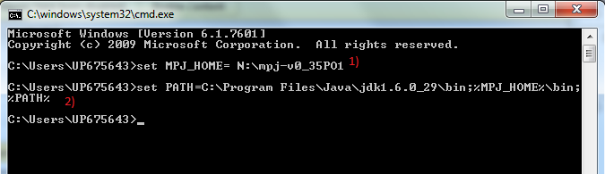
2. Run mpjdaemon :

> mpjdaemon

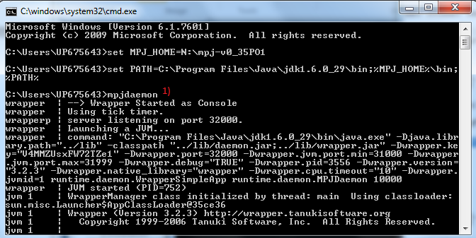

### Running mpjrun

1. Open a command prompt.
2. Set the system variables.
3. Set the value of variable MPJ_HOME.

> set MPJ_HOME=N:\mpj-v0_35PO1

1. Set the value of variable PATH. > set PATH=C:\Program Files\Java\jdk1.6.0_29\bin;%MPJ_HOME%\bin;%PATH%
2. Write a machines file stating IP addresses of the nodes where you wish to execute MPJ Express processes. Save this file as 'machines' in mpj-user directory.





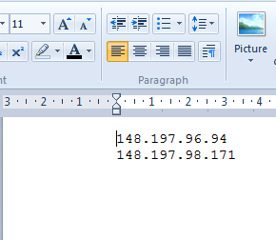

1. Write an MPJ Express program and save in mpj-user directory.
2. Compile the program : > javac -cp .;%MPJ_HOME%/lib/mpj.jar HelloWorld.java

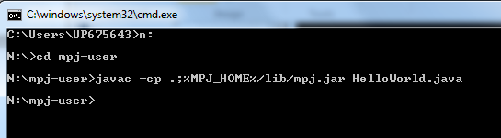

1. Execute the program : > mpjrun -np 2 -dev niodev HelloWorld

